**Introduction**

This report includes technical details, test results, performance results and cost analysis of the flyback converter which is constructed by ISWT. To design 12/48 Volts 80W flyback converter, we started with making simulation about the flyback with given specifications. Then we started to design a transformer according to theoretical expressions and simulation results. During transformer design, we gave importance to magnetizing inductance to provide required mode condition. After that, we started to examine suitable components for our flyback configuration. During this process, we select core material, switch, diodes, capacitors etc. Also we decided to use Arduino to provide switching for selected switching component.

During construction of the circuit on the board, we tried to minimize size of the converter also we gave importance to heat flow of the converter. Since due to high frequency of switching, switching component heated up dramatically during operation. When we constructed the flyback on the board, we started to make test for understanding how our converter works under different loads. Due to some problems, we cannot reach full load operation which is 80W output operation. Figure 1 shows the final view of the converter which is constructed by ISWT.

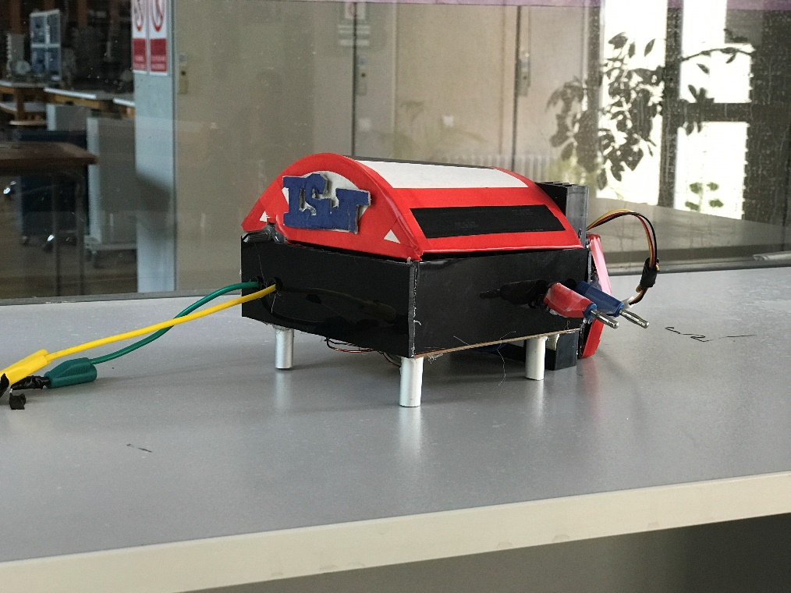

Figure 1:12/48V Flyback Converter which is produced by ISWT